# Starters:

# Baked onion bhajis

A healthier alternative to the deep-fried onion bhajis you find in Indian restaurants. These are baked and exceedingly tasty. They are sweet, tender and very moreish. Serve as an appetiser or starter.

## Serves: 8

**Prep time**: 10 mins

**Cook time:** 1 hr

## Ingredients:

* For the bhaji mix
* 5 small onions, sliced 5mm thick
* 5 tablespoons chickpea flour
* 1 pinch salt
* 1/2 teaspoon ground cumin
* 1/2 teaspoon ground coriander
* Extra virgin olive oil, as needed
* 1 tablespoon tomato puree
* Water, as needed
* Spices for the pan
* 1/2 teaspoon ground turmeric
* 1/2 teaspoon ground coriander
* 1/4 teaspoon ground cumin
* 1/4 teaspoon ground ginger
* 1/4 teaspoon chilli powder

## Method

1. Preheat the oven to 200 C / Gas 6. Line a large baking tray with baking parchment.
2. Gently sweat the onions off in a frying pan with some oil until they turn translucent, about 6-8 minutes.
3. Sprinkle in the chilli powder and mix. Add the turmeric, cumin, ginger, and coriander and stir well. Remove from the heat.
4. Place the chickpea flour, salt, coriander, cumin into a medium bowl and mix well. Add the onions and tomato puree into a bowl and mix. Add a little bit of water to get the correct consistency, it should be wet and easy to stir, but not sloppy.
5. Drizzle some oil onto the prepared tray, place 2 tablespoons of the onion mix onto the tray for each bhaji, flatten slightly with the back of the spoon.
6. Bake on the middle shelf of the oven for 20-25 minutes, drizzle a little oil on top of the bhajis and bake for an additional 25 minutes or until golden brown. Serve hot, enjoy!

# Spicy Grilled Shrimp

# 

Simple and elegant starter! Chilli paste and fish sauce give these shrimp a Thai-inspired flavour. Both are available in the ethnic-food aisles at many supermarkets, in Asian grocery stores, and online.

PREP: 10 MINS

Cook time: 25 MINs

SERVINGS: 12

## INGREDIENTS

### FOR THE SAUCE (MAKES 3/4 CUP)

* 1/2 cup sugar
* 1 teaspoon finely grated lime zest, plus 1/4 cup fresh lime juice (from 3 to 4 limes)
* 1 tablespoon Asian chilli paste (such as sambal oelek)
* 1 tablespoon Asian fish sauce (such as nam pla)
* Coarse salt

### FOR THE SHRIMP

* Safflower oil, for brushing
* 36 large shrimp (about 3 pounds), peeled and deveined (tails left intact; optional)
* Coarse salt

## DIRECTIONS

1. Soak 12 wooden skewers in water for 30 minutes to prevent charring.
2. Meanwhile, make the sauce: Bring sugar and lime juice to a simmer in a small saucepan. Cook, stirring, until sugar dissolves, about 2 minutes. Remove from heat; stir in lime zest, chilli paste, and fish sauce. Season with salt.
3. Make the shrimp: Heat grill to high. Brush grates with oil. Thread 3 shrimp onto each skewer; season with salt. Divide sauce in half; reserve half for serving. Grill shrimp for 1 minute; brush with sauce. Flip, and grill for 1 minute more; brush with sauce again. Flip, and grill, brushing occasionally with sauce, until opaque, 1 to 3 minutes more. Serve with reserved sauce.

# Sweet-and-Sour Chicken Wings

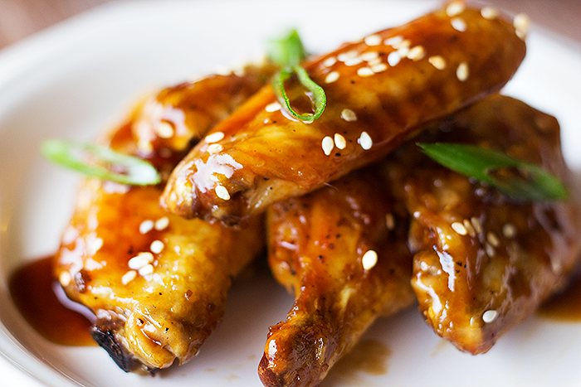

Serve these baked chicken wings as an appetizer; their sweet glaze of honey is counterbalanced by soy sauce and vinegar. Garlic and ginger add a welcome kick, elevating the wings to game-day territory.

PREP: 10 MINS

Cook time: 30 MINS

SERVINGS: 4

## INGREDIENTS

* 1/2 cup soy sauce
* 1/2 cup white vinegar
* 1/2 cup clover or wildflower honey
* 3 garlic cloves, smashed and peeled
* 2-inch piece peeled fresh ginger, thinly sliced
* 3 pounds chicken wings, cut in half at joint (wing tips removed)
* 1 teaspoon sesame seeds, toasted
* 2 teaspoons chopped fresh chives (optional)

## DIRECTIONS

1. Preheat oven to 475 degrees. In a small saucepan, whisk together soy sauce, vinegar, honey, garlic, and ginger. Bring to a simmer over medium-high and cook, stirring occasionally, until mixture thickens and is reduced by half, 30 minutes. Pour through a fine-mesh sieve into a large bowl; discard solids. You should have 2/3 cup sauce.
2. Meanwhile, arrange chicken wings in a single layer on a rimmed baking sheet. Bake until golden, crisp, and cooked through, 35 minutes. Drain fat from sheet and, with tongs, transfer wings to bowl with sauce. Toss until wings are coated and most of sauce is absorbed, about 3 minutes. To serve, sprinkle with sesame seeds and chives, if desired.

# Asian Crab Cakes

Mini crab cakes encrusted with sesame seeds get a kick from wasabi and soy sauce. The toppings of wasabi, mayonnaise, cucumber, and pickled ginger add creaminess, crispness, and tang, as well as colour.

**Serves**: About 24

**Prep time**: 15 mins

**Cook time**: 5 mins

## INGREDIENTS

* 8 ounces jumbo lump crabmeat, picked over well and rinsed
* 1/4 cup plus 3 tablespoons mayonnaise
* 2 scallions, trimmed and finely chopped
* 2 tablespoons soy sauce
* 2 teaspoons wasabi paste
* 1 teaspoon finely grated lime zest
* 1/2 cup plus 2 tablespoons plain fresh or dried breadcrumbs
* 1 English cucumber, for garnish
* 1/2 cup all-purpose flour
* Gold Medal Flour All-Purpose
* 1/2 teaspoon coarse salt
* 1/2 teaspoon freshly ground pepper
* 2 large eggs
* 1 tablespoon water
* 1/4 cup sesame seeds
* 2/3 cup safflower oil, plus more if needed
* 1/2 cup drained pickled ginger, for garnish

## DIRECTIONS

1. Flake crabmeat with a fork in a medium bowl; stir in 1/4 cup mayonnaise, scallions, soy sauce, 1/2 teaspoon wasabi, and zest. Stir in 2 tablespoons breadcrumbs. Cover with plastic wrap; refrigerate 1 hour.
2. Meanwhile, stir together remaining 3 tablespoons mayonnaise and 1 1/2 teaspoons wasabi in a small bowl. Using a vegetable peeler, make 3/4-by-2-inch ribbons from cucumber (you'll need about 24 ribbons, or 1 for each cake). Fold each ribbon into thirds.
3. In a medium bowl, whisk together flour, salt, and pepper. In a small bowl, beat eggs with the water. In a shallow bowl, stir together sesame seeds and remaining 1/2 cup breadcrumbs.
4. Form 1 scant tablespoon crab mixture into a ball; dip in seasoned flour. Flatten into a 3/4-inch-thick disk about 1 1/4 inches in diameter. Repeat with remaining crab mixture. Dip cakes in egg mixture, then dredge in breadcrumb mixture.
5. Heat oil in a large skillet over medium until hot but not smoking. Add half the crab cakes; cook, turning once, until golden and crisp on both sides, about 1 1/2 minutes. Using a slotted spatula, transfer to paper-towel-lined plates to drain. Repeat with the remaining cakes, adding more oil if needed.
6. To serve, dot each crab cake with wasabi mayonnaise, and top with a cucumber ribbon and a piece of ginger.

#### COOK'S NOTES:

To prepare in advance, cook the crab cakes as directed, and then let cool completely. Place on a baking sheet and freeze until firm, about an hour, then transfer to an airtight container and freeze up to 6 weeks. Bake, without thawing, in a 425-degree oven until heated through, 10 to 15 minutes.

# Broiled Shrimp Toasts

This simple and quick version of the dim sum favourite is a healthier, less greasy appetizer than the usual fried shrimp toasts.

SERVINGS: 4

PREP: 20 MINS

## INGREDIENTS

* 4 ounces rock shrimp (or peeled medium shrimp, deveined)
* 1 tablespoon minced shallot
* 2 teaspoons finely chopped peeled fresh ginger
* 1 tablespoon mayonnaise
* 1/2 teaspoon Sriracha (Asian chilli sauce) or other chilli sauce
* 1 teaspoon finely grated lime zest, plus 2 teaspoons fresh lime juice
* 1/2 medium baguette, sliced into 20 thin slices (less than 1/4 inch thick)
* 3 tablespoons unsalted butter, melted

## DIRECTIONS

1. Pulse shrimp, shallot, and ginger in a food processor until a coarse paste forms. Transfer to a bowl. Stir in mayonnaise, Sriracha, and lime zest and juice.
2. Heat broiler. Working in 2 batches, toast bread slices on a rimmed baking sheet 8 inches from heat source until golden brown, about 30 seconds. Remove from oven. Flip bread, generously brush tops with butter, and spread with a thin layer of shrimp paste (about 1 teaspoon each).
3. Broil until shrimp mixture is opaque and cooked through and toasts are browned, about 1 minute. Serve warm.